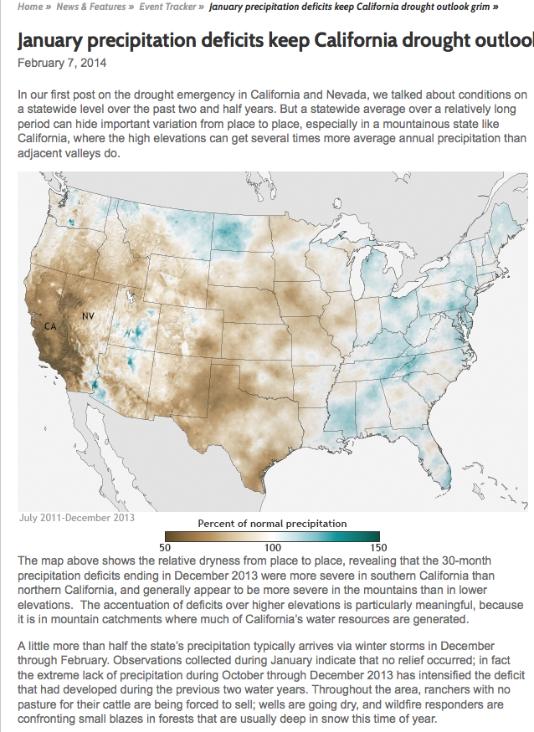
Source:noaa.gov

Given that 20% of the United States Population lives in California and Texas, what are the implications of the drought if it were to continue?

Would you recommend investment in Energy Recovery Incorporated? Why or Why Not?

What will happen to the price of avocados in 2014? Why?

